**4.2 Dynamic models**

**4.2.1 Sequence diagrams**

**4.2.1.1 View Credits**

**Scenario:** In an already started game session it is Player Cengiz’s turn and player enters the “View Credits” command to see the game credits. Credits displayed on the console after Player is done reading the credits Player enters “Return Game” command to return the actual gameplay.

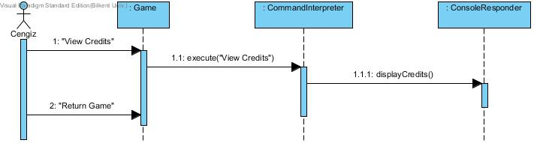

**4.2.1.2 Play game**

**Scenario:** Assumed player Cengiz already set up the character as a Rogue called *Terminator* and familiar with the dynamics of the game. In this game session Cengiz sees the one box above the character currently occupies is not empty, to interact with that map location Player types “Go North” this results in Terminator interacting with another character (a NPC) in the game. NPC reveals a quest to Cengiz in the console. The quest is battling an enemy to the death in the north and be victorious! Cengiz enters “Go West” since he has to travel around the NPC and continues to travel to the north by typing “Go North” until an encounter with the Damned Ghoul. After this encounter the battle map is activated. Player types “Backstab” to attack the Ghoul, console prints “Attack Successful!” now the turn is Ghoul’s, console prints “Ghoul has bitten you!” now Cengiz must make his move he types “Poison Knife” resulting in 1 poison potion destructed from user’s inventory as cost of this attack and console prints “Attack successful!” following “Damned Ghoul is slaughtered” at this point Terminator is rewarded with the quest item and now needs to continue to roam the map to find the new quest to lead him to the other victories!

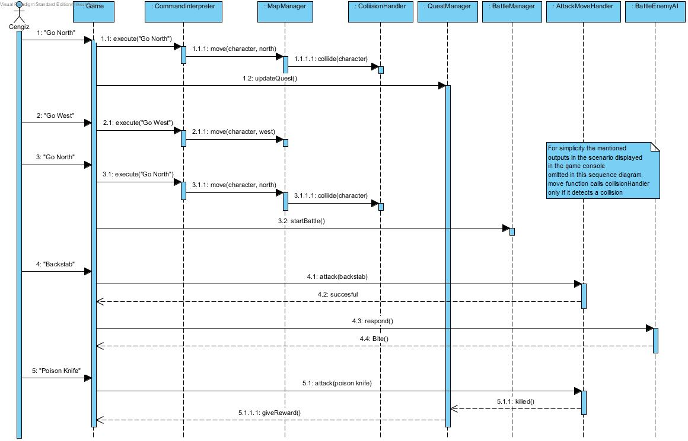

**4.2.1.3 View Help**

**Scenario:** Cengiz clicked the help option to view the help document. After reading it Cengiz learned that he can check how he is doing in the game so he typed “Statistics”. Game returned his Level, quest completeness percentage and score. After viewing them in the console he types “Return Game” to continue with the gameplay.

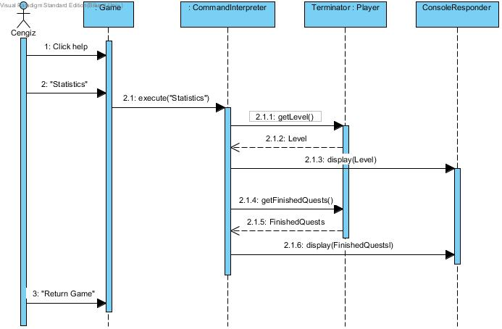

**4.2.1.4 Save Game**

**Scenario:** After making some progress Cengiz decides to save his progress but to do so he must proceed to town center and type “save game” town center is located two blocks south and one block west. After reaching town center he types “save game” and console responds to him “save successful!”

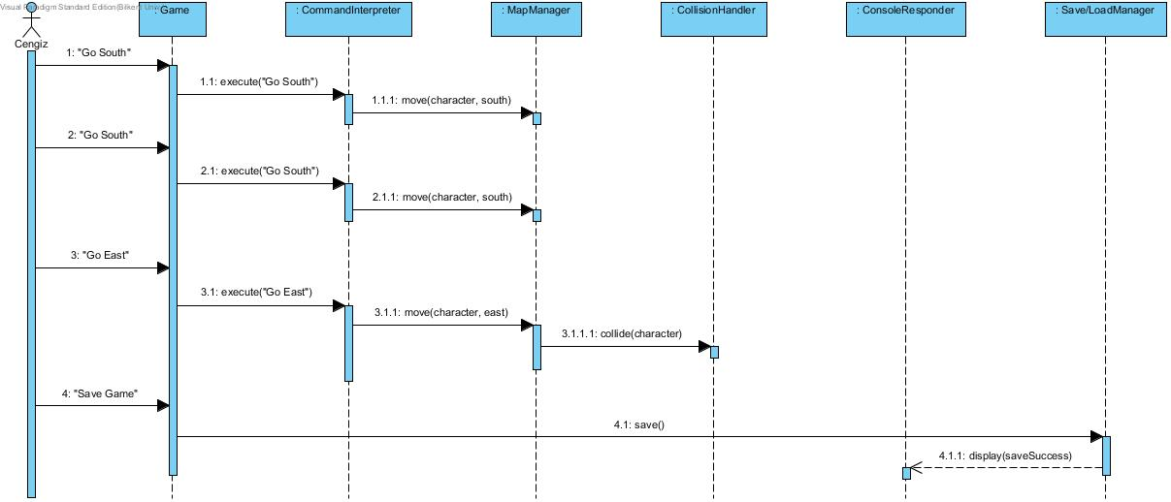

**4.2.1.5 Load Game**

**Scenario:** To continue with a former game session Cengiz selects load. His previous game is loaded and he continues to play from the save point of the game.

